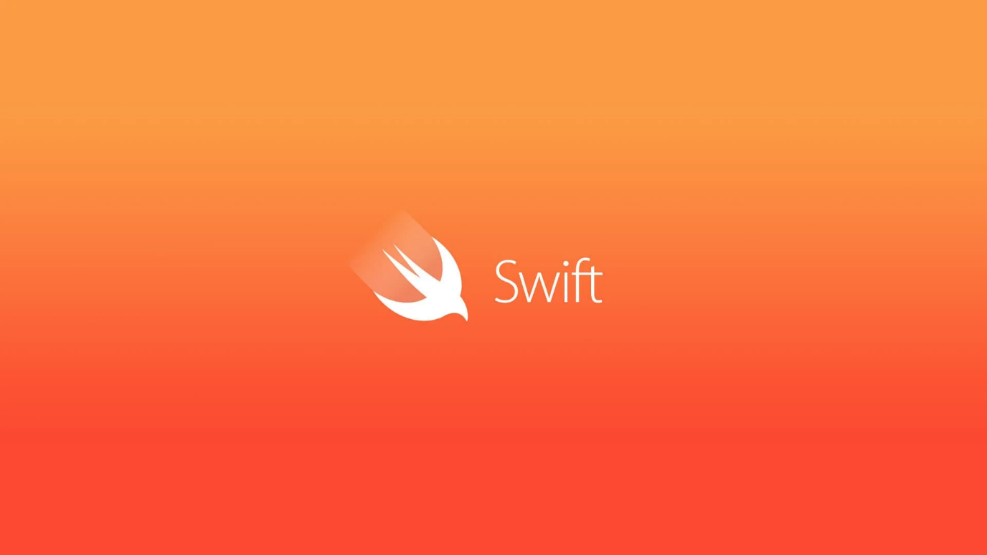

Swift Programs Starter 1.1

By Prateek Panwar

Index

|  |  |  |
| --- | --- | --- |
| Practical | Program | Page No. |
| 1 | Program to Add 3 Numbers & Find Factorial. | 4 |
| 2 | Program to check Prime Number. | 6 |
| 3 | Programs to find computed property. | 7 |
| 4 | Program to find reverse array. | 8 |
| 5 | Program to demonstrate Structure. | 9 |

1. Program to Add 3 Numbers & Find factorial.

Ans. Program:

import Foundation

func Add3Num(a: Int, b: Int, c: Int)

{

var sum = 0

sum = a + b + c

print("Answer = \(sum)")

}

func Factorial(x: Int)

{

var sum = 1

for i in 1...x

{

sum = sum * i

}

print("Factorial of \(x) = \(sum)")

}

Add3Num(a: 2, b: 3, c: 10)

Factorial(x: 5)

Output:

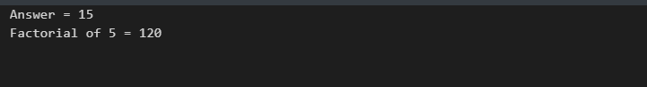

1. Program to check if number is prime.

Ans. Program:

import Foundation

var num = 12

var prime = true

func CheckPrime(num: Int)

{

for i in 2...num-1

{

if (num % i == 0)

{

prime = false

}

}

if (prime == false)

{

print("\(num) is non prime")

}

else

{

print("\(num) is prime number")

}

}

CheckPrime(num: 11)

Output:

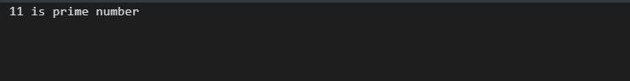

1. Program to demonstrate computed property.

Ans. Program:

import Foundation

struct Temperature {

var celsius: Double

var fahrenheit: Double {

celsius * 1.8 + 32

}

var kelvin:Double {

celsius + 273.15

}

}

let currentTemperature = Temperature(celsius: 30.0)

print(currentTemperature.fahrenheit)

print(currentTemperature.celsius)

print(currentTemperature.kelvin)

Output:

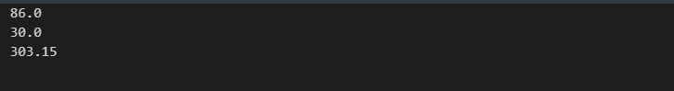

1. Programs to print reverse Array.

Ans. Program:

import Foundation

var a = [Int]()

var len = 0

a = [1,2,3,4,5]

len = a.count

for i in stride(from: len-1, through: 0, by: -1)

{

print("\(a[i])")

}

Output:

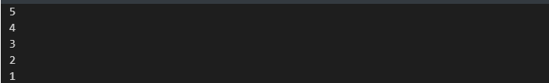

1. Program to demonstrate Structure.

Ans. Program:

import Foundation

struct Length {

var meter: Double

var foot: Double {

meter * 3.281

}

}

let l = Length(meter: 5.0)

print("\(l.meter) Meter = \(l.foot) Foot")

Output:

